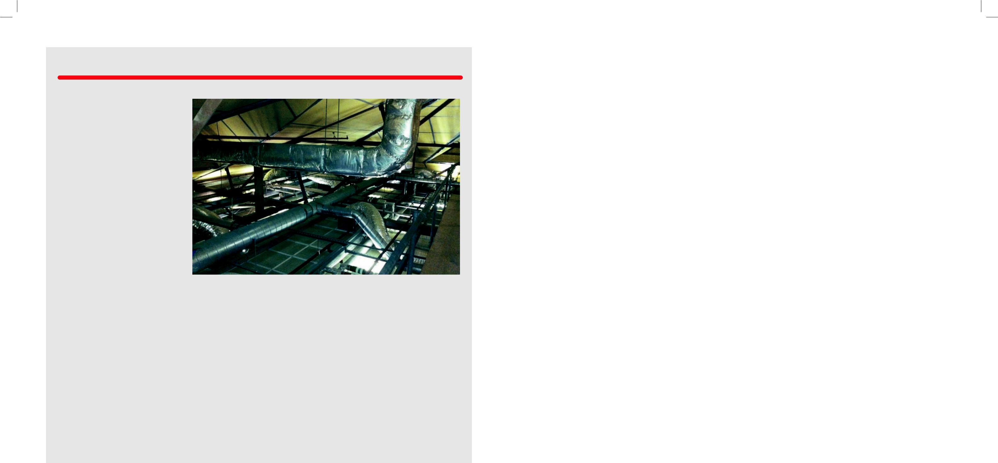
ENGINEERING
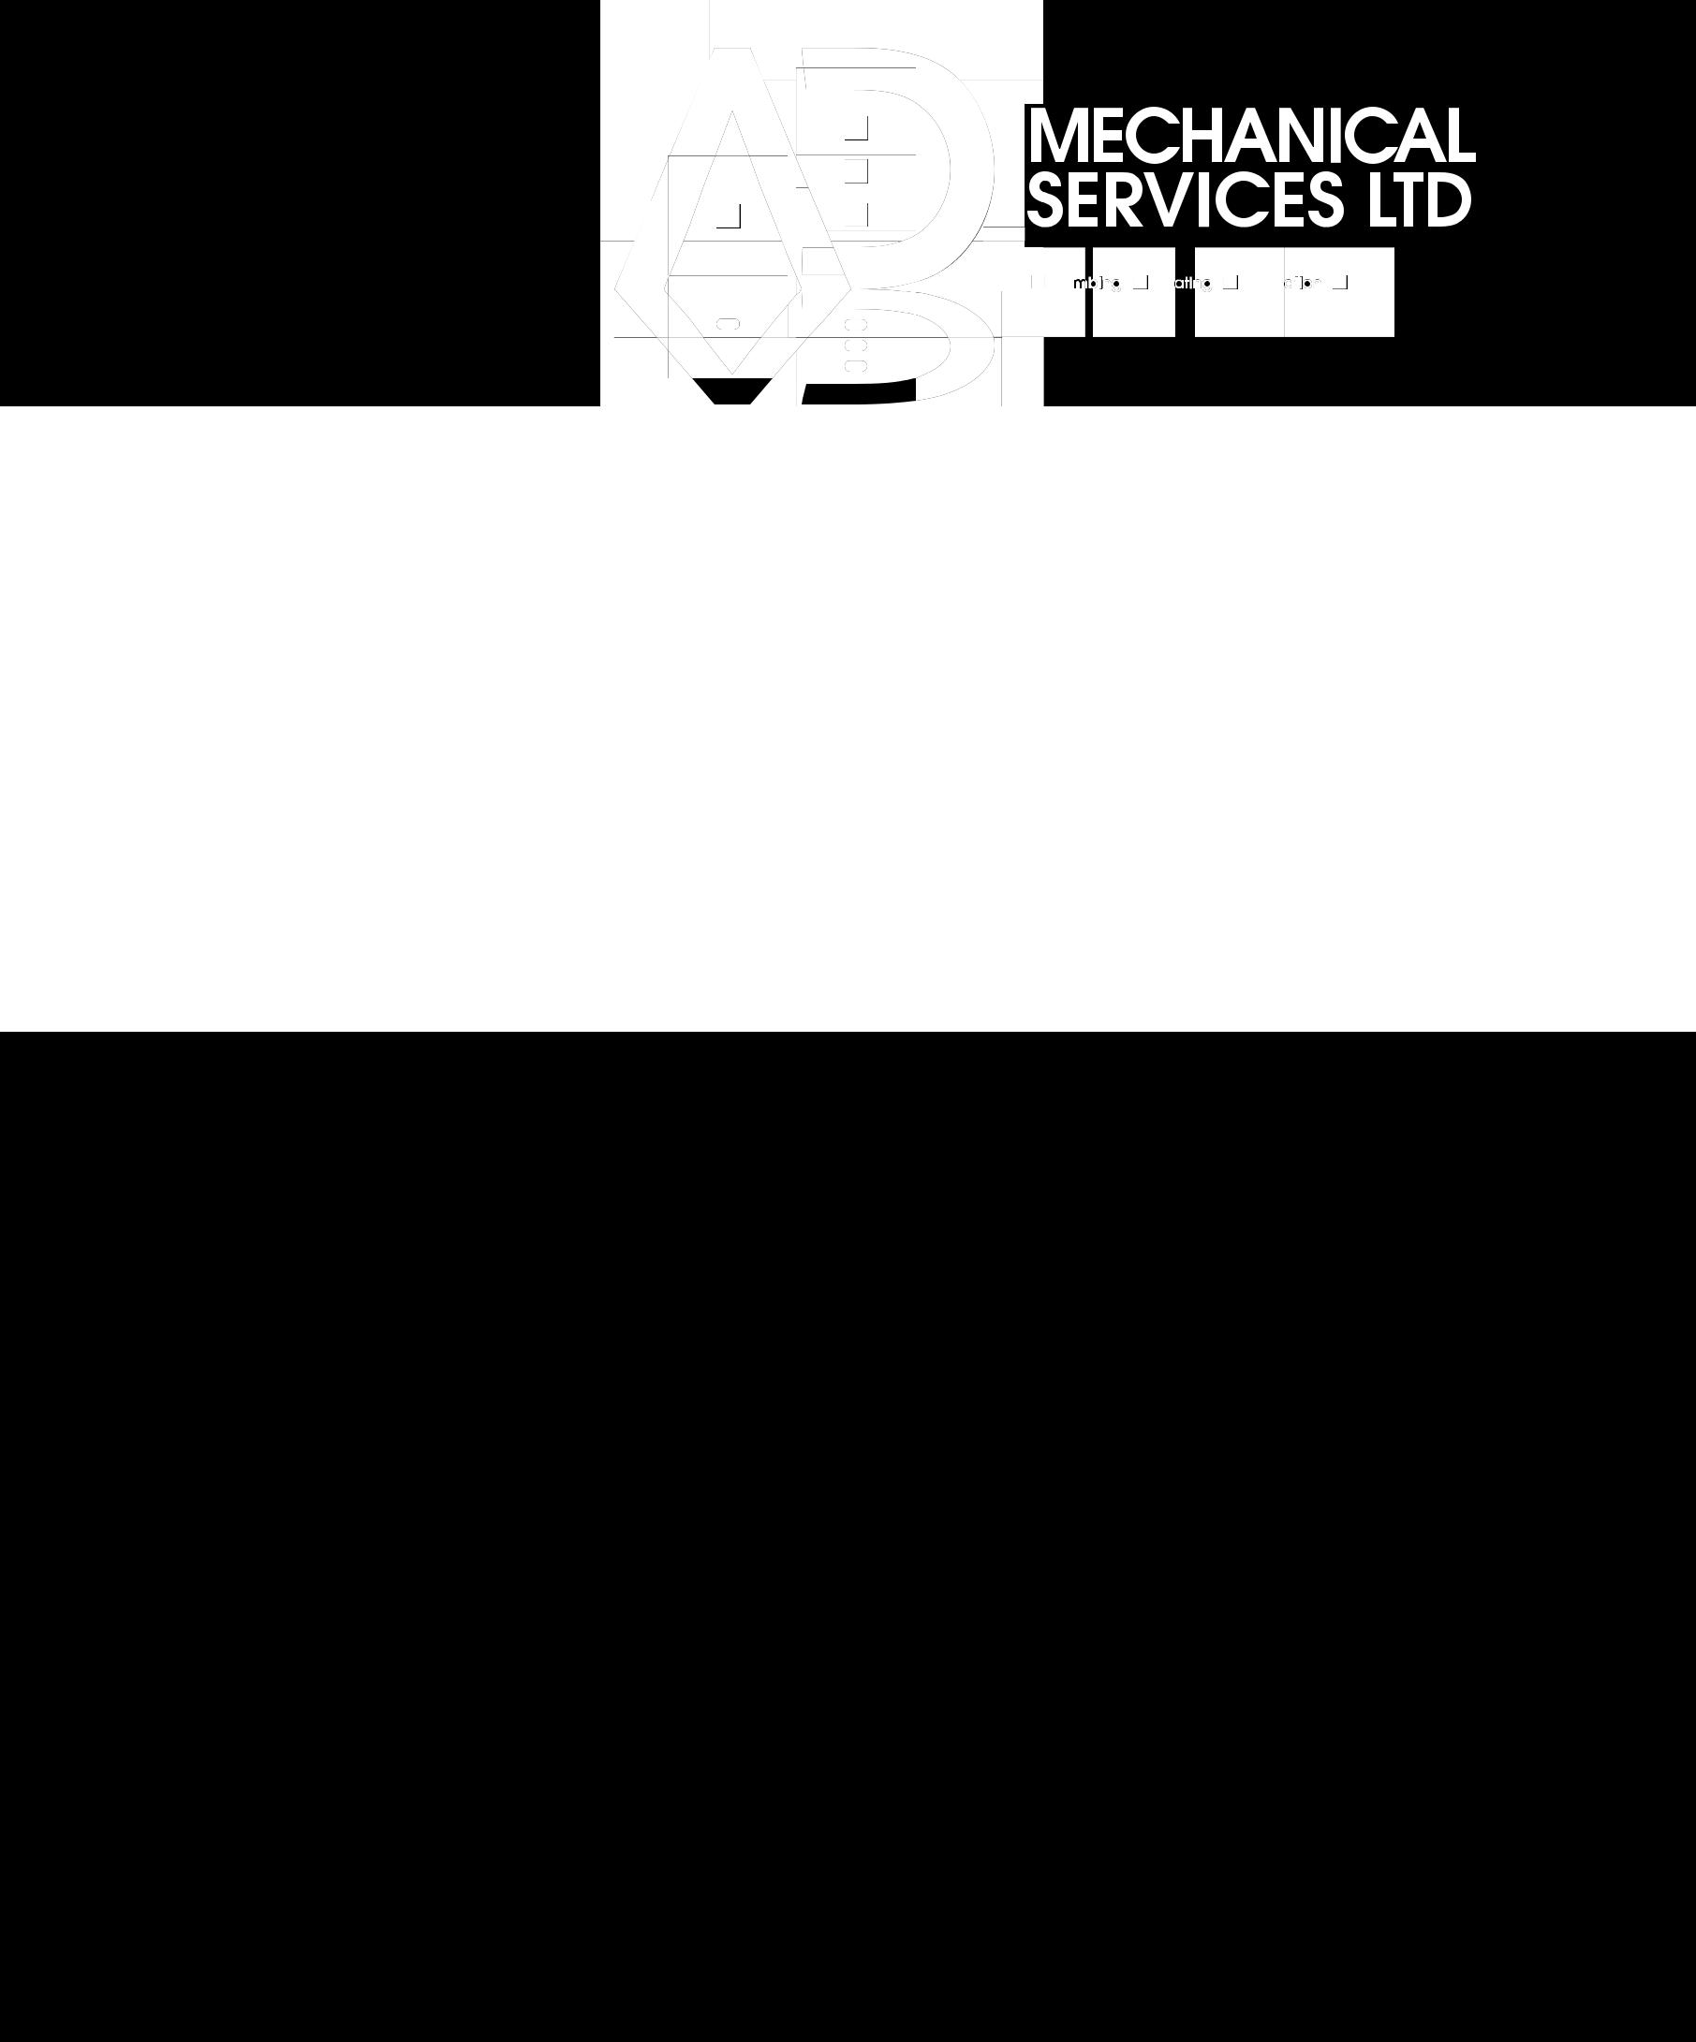
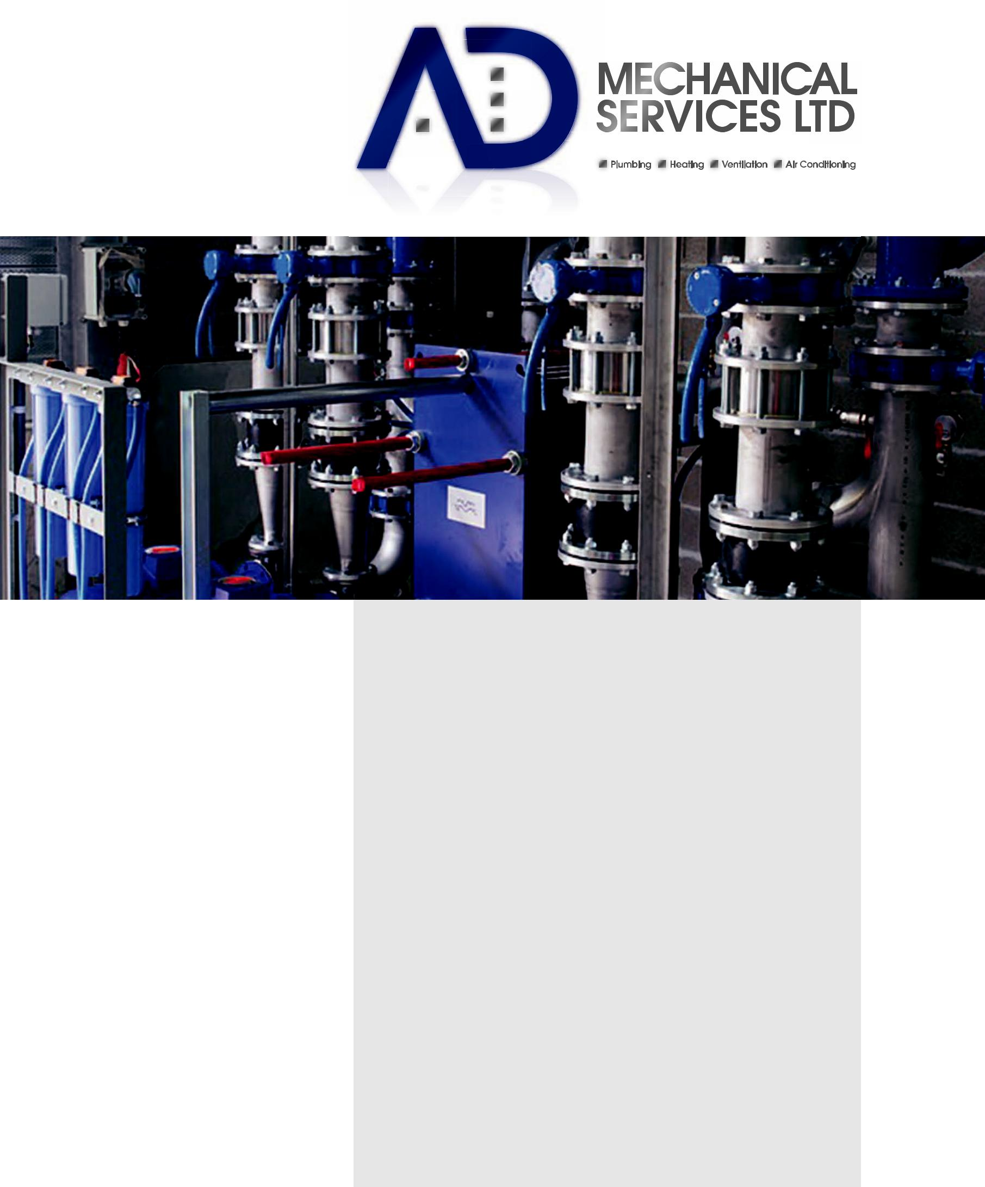

Our Engineers are selected to suit individual projects.

Our contract teams consist of a Contracts Manager, Design Manager (if D&B), AutoCAD Draughtsman, Foreman, and installation operatives.

Our Contracts Managers are responsible for ensuring the services provided by AD Mechanical meet with the high standards expected from our clients. They carry out the day to day engineering and management processes.

Duties include; site safety; procurement; programming; allocation of labour; supervision; commissioning and testing.

Our Contracts Managers are also on hand to liaise with client’s representatives.

Projects are reviewed at our fortnightly management meetings, whereby reports are updated and issued to the client if required.
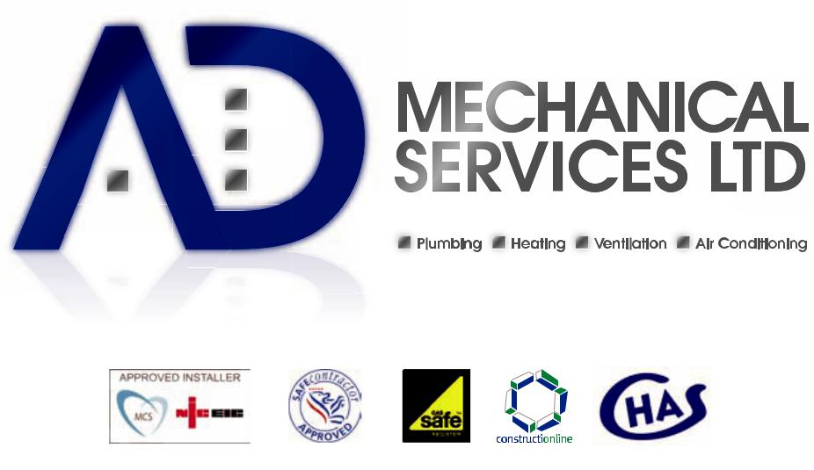

Our Contracts Managers are also provided training in the following:-

- CSCS Health & Safety

- SMSTS Health & Safety

- WRAS Guidelines

- Unvented G3 Hot water regulations

- GasSafe Regulations

- Asbestos Awareness

- Legionella Appreciation

AD Mechanical Services Ltd was

incorporated in December 2000.

From the beginning we have aimed to

provide a professional and competitive

service. We have formed a long lasting

relationship with many clients, often

whereby projects have been negotiated

without competition.

Units 6 & 7 n Fairways Business Centre n Airport Service Road n Portsmouth n PO3 5NU t: 023 9261 7070 f: 023 9261 8080 e: info@admechanical.co.uk www.admechanical.co.uk

AD Mechanical Services Ltd strive for

ongoing improvement, professionalism

and quality.

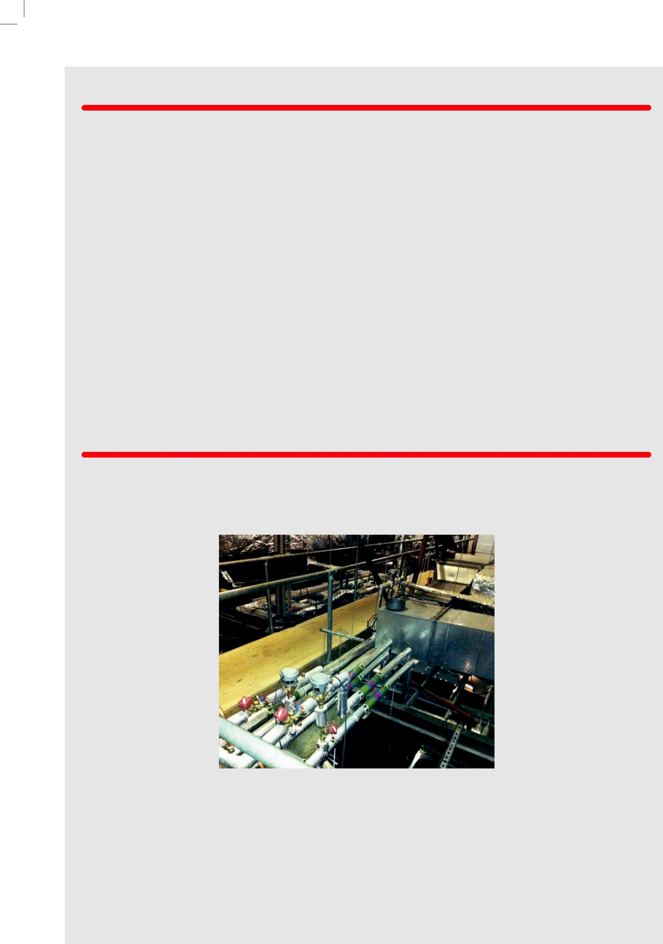
SERVICES

DESIGN
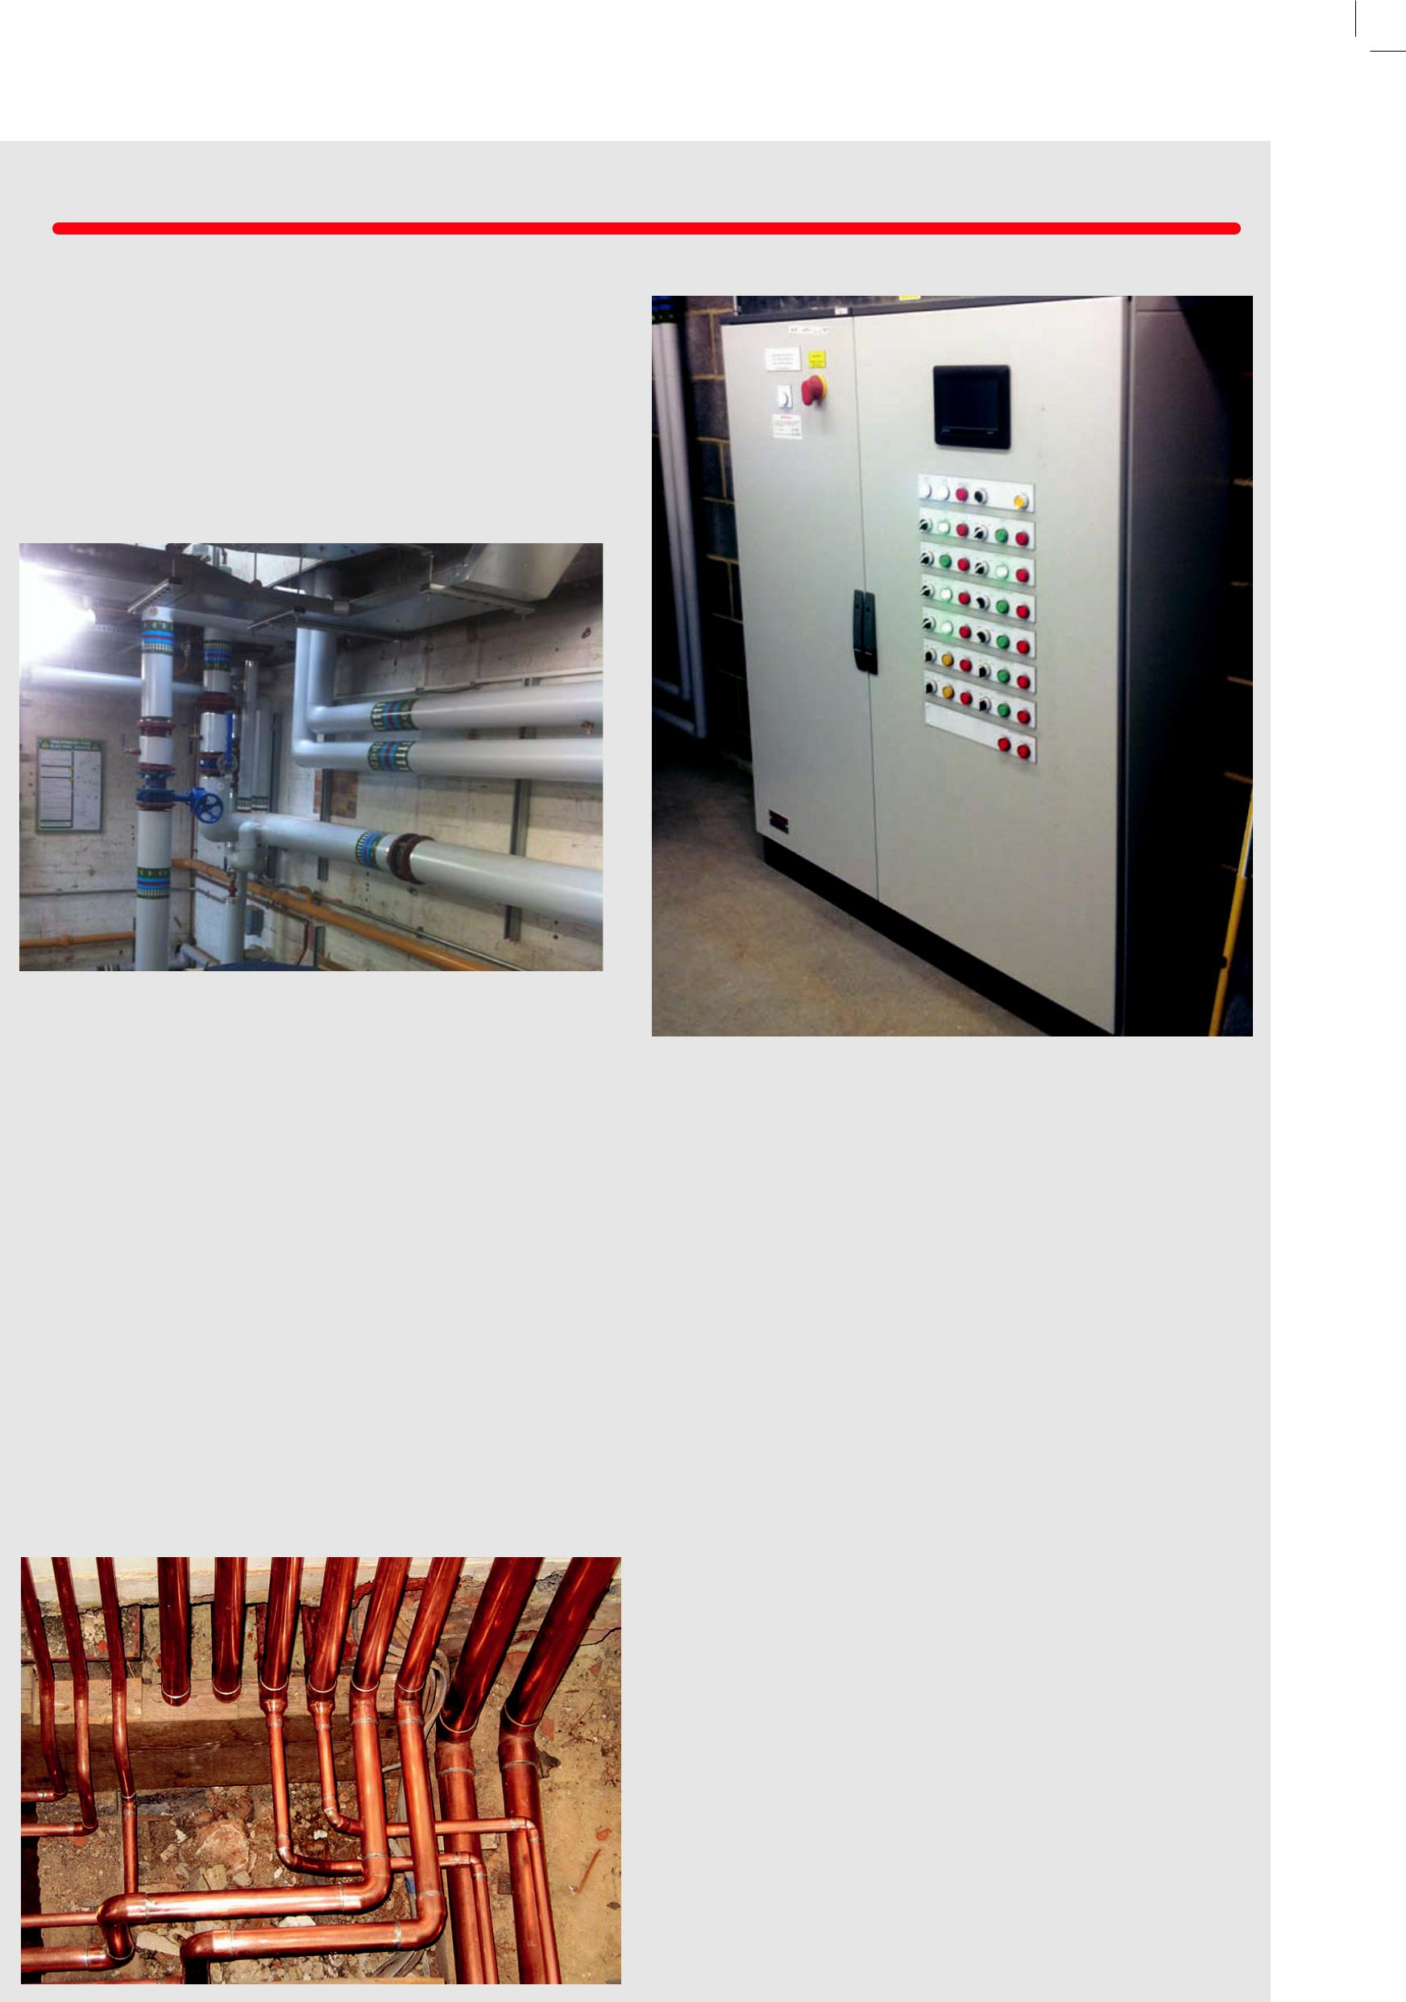

n | LPHW Heating | n External Water & Gas mains
n | MPHW Heating | n | Rainwater Harvesting
n | Domestic Services Installation | n Dust & Fume Extraction
n | Above Ground Drainage | n | Fan Coil Installation
n | Plant Rooms | n | Science Laboratory Drainage
n | BMS Controls | n | Chiller Plant Installation
n | Air Conditioning Installations | n | Insulation Services
n | Heat Pump Installations | n Electrical Installations (in partnership)
n | Heat Recovery Ventilation | n | Water Treatment
n Supply & Extract Ventilation |  | n | Legionella Water Management

- Gas Installations

PROJECTS

All types of mechanical | recent projects have included the | changing need of the staff and
services projects are | conversion of an office building | patients.
undertaken on a pre- | to a residential apartment block.

designed, or design We have completed

and build basis but demanding projects within

always on a friendly and local hospitals and schools

non contractual basis. including; St Mary’s

Projects can range from Hospital, Portsmouth;

£5k to £2.5million. Frimley Park, Camberley;

We have carried out St Mary’s IOW; Battenburg

various new installations Clinic, Goldsworth

ranging from new plant Primary School, Woking,

rooms at Universities Bulmershe School, Woking

and Schools, Air and Mayfield School

conditioning systems to Portsmouth

new offices, underfloor
heating systems to sports | We are also well conversed in | We are also well known for our
pavilions & new chiller and AHU | working within occupied premises | design and installation schemes
plant installations to mutiple | such as hospitals, institutions, | in domestic new build projects for
storey office buildings. | doctor’s surgeries and retirement | housing associations in the south
 | homes. Such projects necessitate | of England. We currently carry out
Refurbishment and conversion | understanding and sensitivity in | over 500 unit installations
projects are also undertaken, | carrying out tasks around the ever | per year n

We provide a full mechanical design

and build service, and provide a dedicated team equipped and trained using the latest software technology including Hevacomp and AutoCAD Building Design Suite.

We now also have the capabilities to work within BIM Modelling process, and are able to provide many additional services such as the following:-

- A fully accredited energy performance certificate (epc) service

- A fully accredited part l2a compliance checking and advisory service

- Full dynamic modelling of buildings

- Energy and CO₂ emissions assessments

- Advice on sustainability design concepts

- Building fabric and renewable strategies for low energy design

- Assistance with breeam evidence

- Value engineering

We will work with our client to obtain project compliance with the latest building regulations, BREEAM recommendations and energy conservation measures.

Designs are undertaken from an initial brief, a site survey, or a fully detailed scheme. On this basis we ensure the project design is cost effective, user friendly and easy to maintain. Everything is produced to suit client specific requirements and budget constraints.

We pride ourselves on producing a quality design package including detailed design data, equipment schedules, coordinated drawings, and builders work requirements n

